We providers some client application that you can used to connect allproxy server, you need to use different app for dongles or phone.

We assuemes that you have done the server side deployment, so that in here we just introduce how to connect server in client side.

# Dongles

For dongles, we just tested some models, includes Huawei E3372, E8372, E3276,CLR900A, if you want to use other kind of devices, you can provider a ENV where I can test that device.

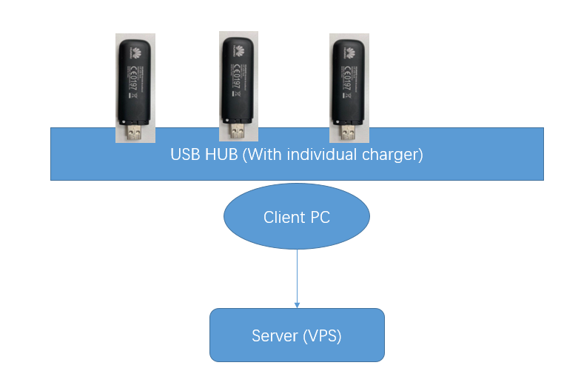

## The Required steps for dongles

You know, the IP gateway is same in one dongle kind, for e.g, most of dongle has same default gateway 192.168.7.1, in that case, we cannot use multiple dongles in same pc.

But we can change it in that management page manually, so you can just edit it to different range, such as 192.169.8.1, 192.169.9.1, 192.169.10.1 …..

And we also providers a GUItool for huaweiE3372 (For other kind of device, you can edit it in manually or our console version)

<https://github.com/xapanyun/4gproxy/tree/master/Tools>

## The application we need --- Windows PC

1. AllproxyC

You can download it from: <https://github.com/xapanyun/4gproxy/tree/master/Windows/console/x64>

Pls donwload allproxyC.exe, conf_client.yaml, and put it in same directory.

Then just change the Server Address.

1. clientUtilities

This tool is used to do IP rotaion, you can download it from

<https://github.com/xapanyun/4gproxy/tree/master/Tools>

1. IP rotaion configuration

There are 2 important options in conf_client.yaml.

**LocalAddr**

Our client pc may have a internet network that not from dongle, and it’s maybe our Home Wifi, and it’s faster then dongle, so we can use it to comminication with our VPS server.

In this case, we can enable localAddr option, and set its value to the correct local pc LAN address, such as:

*localAddr: 192.168.2.101*

**commands**

We must set valid commands here for each device, because it will be used to do ip rotaion.

E.g:

commands:  
 "192_168_7_100": 'C:/Users/nxu/allproxy/clientUtilities -deviceMode e3372 -params $IP'  
 "192_168_10_100": 'C:/Users/nxu/allproxy/clientUtilities -deviceMode e3372 -params $IP -command reboot'

In above, “192_168_7_100” and "192_168_10_100" is the network adapter ip address.

BTW, you can also use ADB command in above for android (Enable usb tethering and connect to client PC).

## For Linux

Because we have to deploy some script to make Linux works on multiple network adapters, so it’s difficult to configuration.

The magic is here: <https://github.com/xapanyun/4gproxy/tree/master/Linux/N1>

But it’s really hard if you are not familiar with Linux network, so pls ask me to deploy it if you want Linux client.

# Android

It’s very easy for android, you can just install our APP, and set correct server address/api address(Not required if non-root), it will works.

<https://github.com/xapanyun/4gproxy/tree/master/android>

NOTE: For ip rotaion, the andorid device must be rooted

## GUI client Application

<https://github.com/xapanyun/4gproxy/tree/master/Windows/gui>

We had stop maintain it long days, but it may easier for end user, so we will restart development for it in this year.